- Designed a VPC with public and private subnets across multiple AZs (Bastion Architecture)

- Created VPC
• Name: My-VPC
• IPv4 CIDR: 10.0.0.0/16

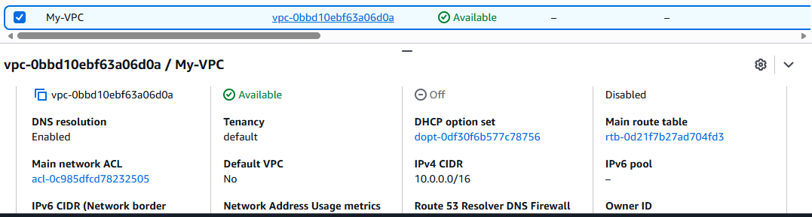

- Created public and Private subnets with different availability Zones

Public Subnets
- Public-Subnet-1
  - CIDR: 10.0.1.0/24
  - AZ: ap-south-1a
- Public-Subnet-2
  - CIDR: 10.0.2.0/24
  - AZ: ap-south-1b
Private Subnets
- Private-Subnet-1
  - CIDR: 10.0.3.0/24
  - AZ: ap-south-1a
- Private-Subnet-2
  - CIDR: 10.0.4.0/24
  - AZ: ap-south-1b

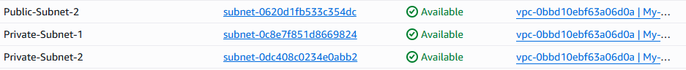

3.Created Internet Gateway (IGW) and attached VPC
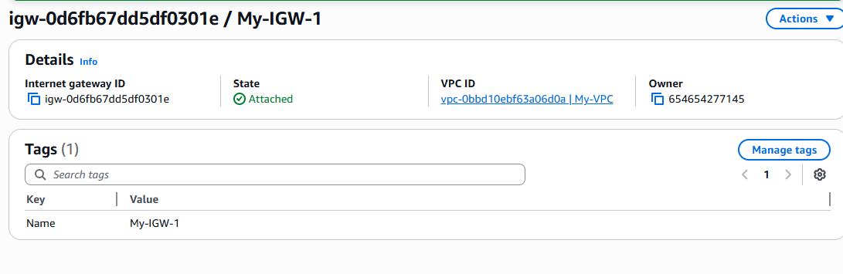4.Created Route Table (Public)
- Create Route Table → Public-RT
- Attached to VPC
Added Route:
Destination: 0.0.0.0/0
Target: Internet Gateway

Associated with both public subnet
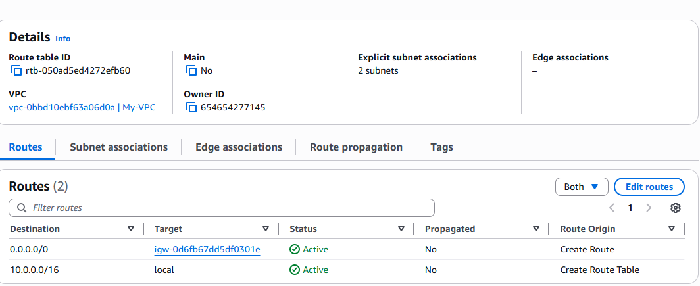
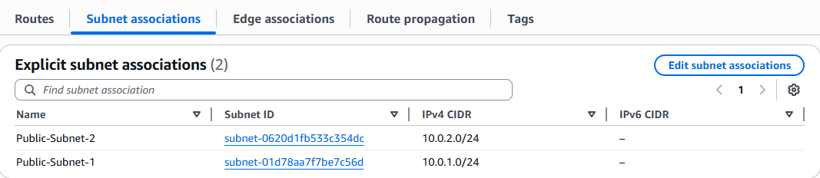

5.Enabled Auto Assign Public IP

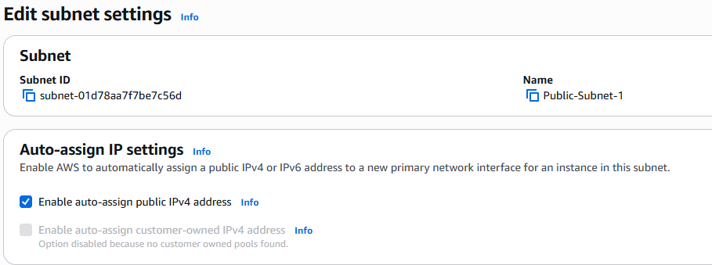
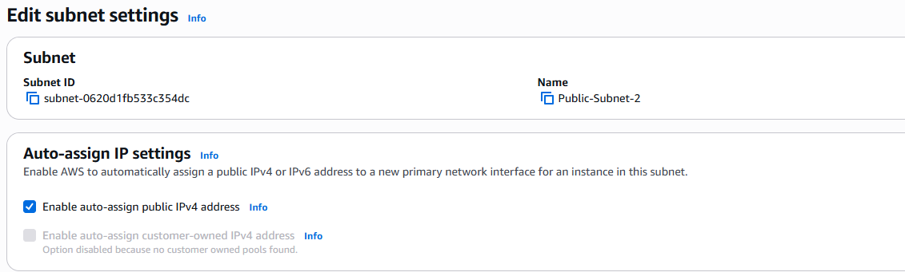
6.Created NAT Gateway
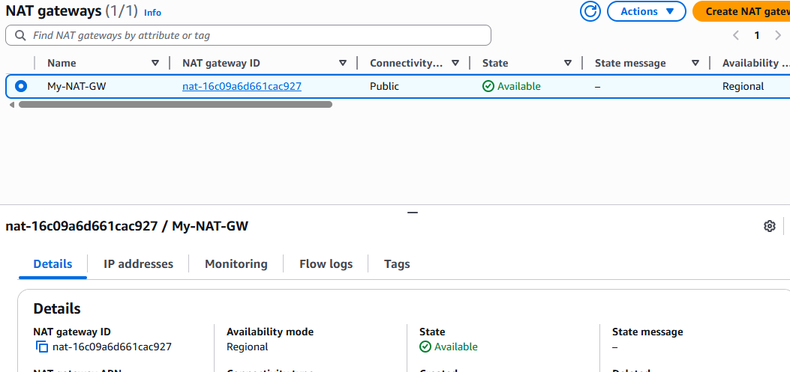

7.Created Private Route Table and attached VPC and private subnets
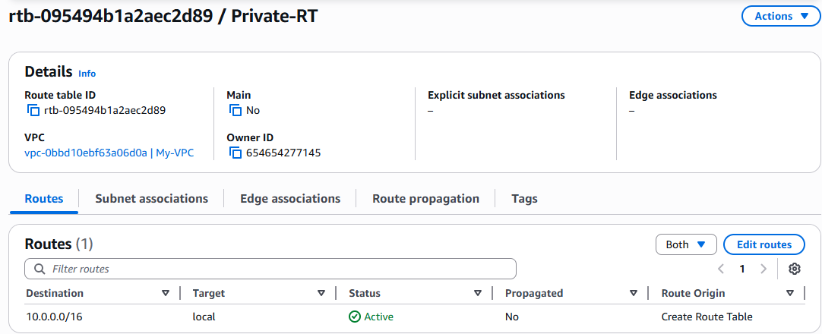
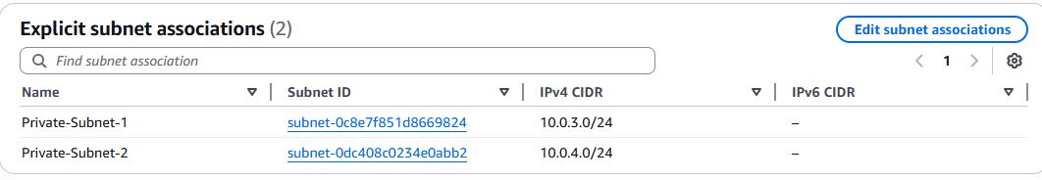
Added Route:
Destination: 0.0.0.0/0
Target: NAT Gateway

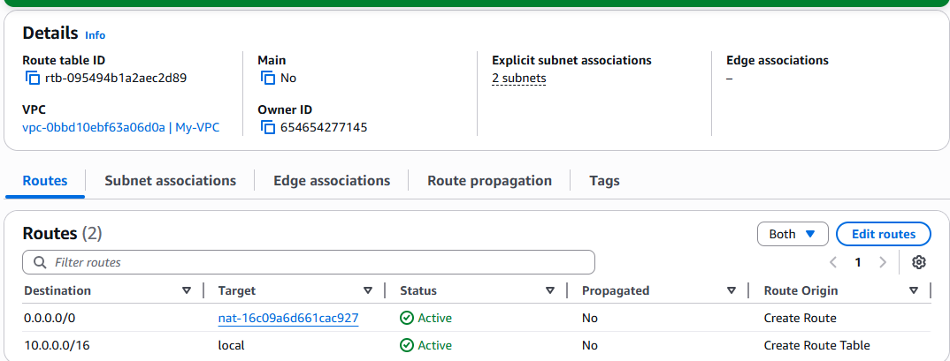

8.Launched Public EC2 Instance
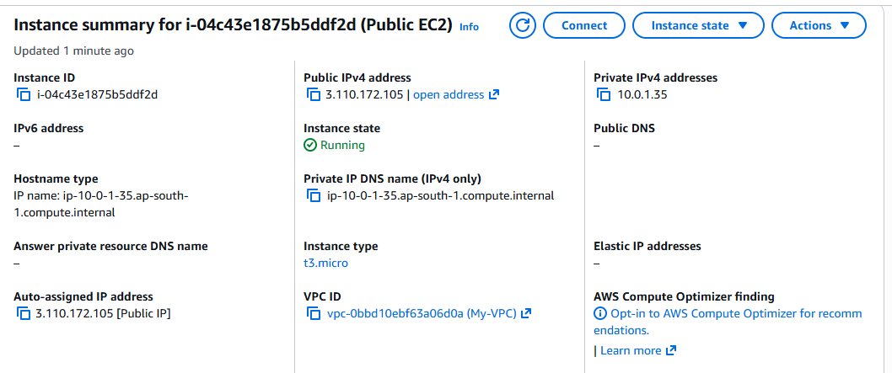
9.Launched Private EC2
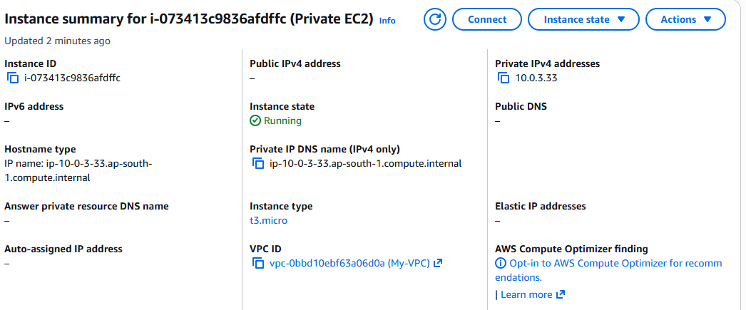
10.Tested the connectivity
From Where | Which IP to Use
Laptop → Public EC2 | ✅ Public IP
Public EC2 → Private EC2 | ✅ Private IP
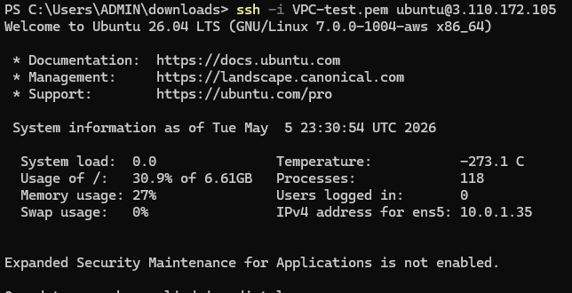

11.Commands used :
*cd downloads
*ls- to check key pair file
*ssh -i keypair.pem ec2user@public_Ip
(ssh -i VPC-test.pem ubuntu@3.110.172.105)
* ssh -i keypair.pem ec2user@private_IP
(ssh -i VPC-test.pem ubuntu@10.0.3.33)

Key Components Used
- Amazon VPC (custom CIDR)
- Public & Private Subnets
- Internet Gateway (IGW)
- NAT Gateway
- Route Tables
- EC2 Instances (Public + Private)
- Bastion Host Architecture
- Security Groups & NACLs
- SSH (Key-based authentication)

